
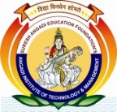
SURESH ANGADI EDUCATION FOUNDATION’S
ANGADI INSTITUTE OF TECHNOLOGY AND MANAGEMENT
Savagaon Road, Belagavi – 590 009.
(Approved by AICTE, New Delhi &Affiliated to Visvesvaraya Technological University, Belagavi)
Accredited By NAAC

Department of Mechanical Engineering
Association of Mechanical Engineering
Event Report
on

TECHNICAL TALK ON MODELLING SOFTWARES

Event conducted on 30th April 2024

Mr. R H Angadi Mr. Malagouda Patil
Event Coordinator HOD

Mr. Malagouda Patil Dr. Anand Deshpande
IQAC Coordinator Principal & Director

Content of the Report

- Object of Event:
- Brief introduction of the event
- Relevance to PO:
- Audience Target (Internal or External, Students or Faculty etc.):
- Speaker Invite Letter/ Profile/ Details:
- Venue, Date and Time:
- Geo tagged photos of event conducted for evidence:
- Conclusion

1. Object of Event:
Objective of this event is to make students understand different opportunities in the field of Mechanical Modeling Softwares and Job Opportunities.
2. Brief Introduction of the Event
The Department of Mechanical Engineering has been organizing department level technical talks and career guidance program. This event was conducted through association of mechanical engineering (AME) with the assistance of college placement cell. These events are found to be useful for students in discovering different career opportunities. Modern mechanical software tools, such as CAD and CAM programs, have transformed the field of mechanical engineering, enabling precise design, simulation, and manufacturing processes that significantly improve efficiency and innovation
3. Relevance to PO’s:
The following PO’s are relevance to the event
- Engineering Knowledge
- Modern Tool Usage

4. Audience Target (Internal or External, Students or Faculty Etc.):
The audience for the events is in house participant only the students of Mechanical engineering department. The total participant strength is around 40 numbers.
5.Speaker Invited
MR- Kiran Rokade(SYNKOC IT Service Private Limited) Bangalore
6. Venue, Date and Time:
Event was conducted in CAD lab on 30 April 2024 at 10.00 AM
7. Geotagged Photos of Event Conducted for Evidence:
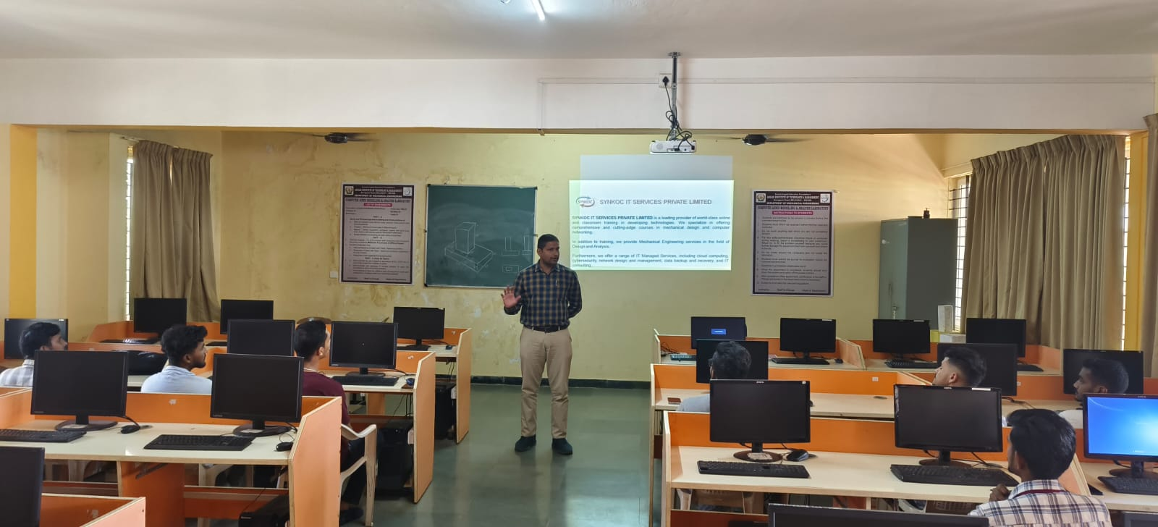

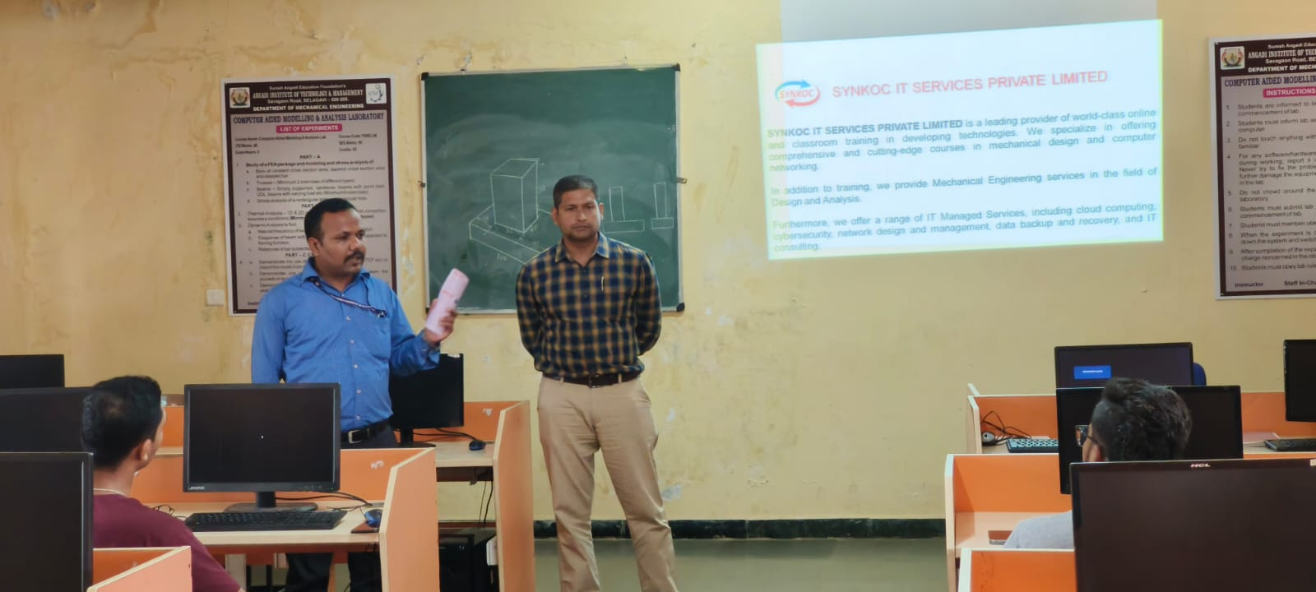

8. Conclusion
The event was enlightening to students regarding different career opportunities and also it cleared the doubts of many students regarding computer Software tools and application in Mechanical engineer.

